Dementia Prediction Using Machine Learning: A Comprehensive Statistical and Computational Analysis
Author: Abishek Kumar Giri
Stockton University – Data Mining & Machine Learning Research Project (2024)

Executive Summary

This research study applies advanced machine learning, statistical inference, and explainability tools to analyze dementia prediction using the OASIS longitudinal dataset. Results reveal that cognitive metrics such as the Clinical Dementia Rating (CDR) and Mini-Mental State Examination (MMSE) are the strongest predictors. Machine learning models achieved near-perfect accuracy, and inferential statistics confirmed significant differences across key clinical variables. This report documents the methodology, experiments, statistical results, and conclusions in a scientifically rigorous and academically appropriate format.

Abstract
This research investigates dementia prediction using demographic and cognitive indicators from the OASIS longitudinal dataset. Statistical tests,including t-tests, chi-square tests, and ANOVA were conducted to determine variable significance. Machine learning algorithms such as Logistic Regression, Random Forest, Gradient Boosting, and SVM were evaluated, producing exceptionally high accuracy and AUC scores. Feature importance and SHAP explainability confirm that CDR and MMSE dominate predictive relevance, aligning with existing clinical research. The findings support the viability of machine learning as a decision-support tool in cognitive impairment assessment.

1. Introduction
Dementia affects millions worldwide and poses major medical and economic burdens. Timely detection can delay progression and improve care outcomes. Traditional diagnostic tools rely on cognitive tests and clinician interpretation. This study explores whether machine learning models trained on validated clinical and demographic variables can effectively identify dementia patterns. Additionally, statistical testing is performed to understand variable relationships and significance.

2. Methodology

2.1 Dataset
The dataset is sourced from the OASIS longitudinal neuroimaging project. The variables include Age, Gender, Education Level, Socioeconomic Status (SES), MMSE, CDR, and dementia label.

2.2 Preprocessing
Data was merged, cleaned, and standardized. Missing values were removed, categorical variables were encoded, and Z-score normalization was applied to continuous features. Dataset balancing was performed through controlled downsampling.

3. Inferential Statistical Tests

3.1 Two-Sample t-Tests
Variable | t-statistic | p-value | Interpretation
Age | -2.31 | 0.021 | Significant difference between groups.
Education | -3.10 | 0.002 | Significant difference.
MMSE | 8.92 | <0.001 | Highly significant difference.
CDR | 12.40 | <0.001 | Extremely significant difference.

3.2 Chi-Square Test for Categorical Variables
Variable | Chi-square | p-value | Interpretation
Gender | 1.12 | 0.291 | Not statistically significant.

3.3 ANOVA Analysis
Variable | F-value | p-value | Interpretation
Age | 4.10 | 0.044 | Moderately significant.
Education | 6.22 | 0.014 | Significant difference.
SES | 1.90 | 0.171 | Not significant.

4. Machine Learning Model Performance
Model | Accuracy | Precision | Recall | F1-Score | AUC
Logistic Regression | 0.94 | 0.89 | 1.00 | 0.94 | 1.00
Random Forest | 0.98 | 0.96 | 1.00 | 0.98 | 0.99
Gradient Boosting | 0.98 | 0.96 | 1.00 | 0.98 | 1.00
SVM (RBF) | 0.94 | 0.89 | 1.00 | 0.94 | 1.00

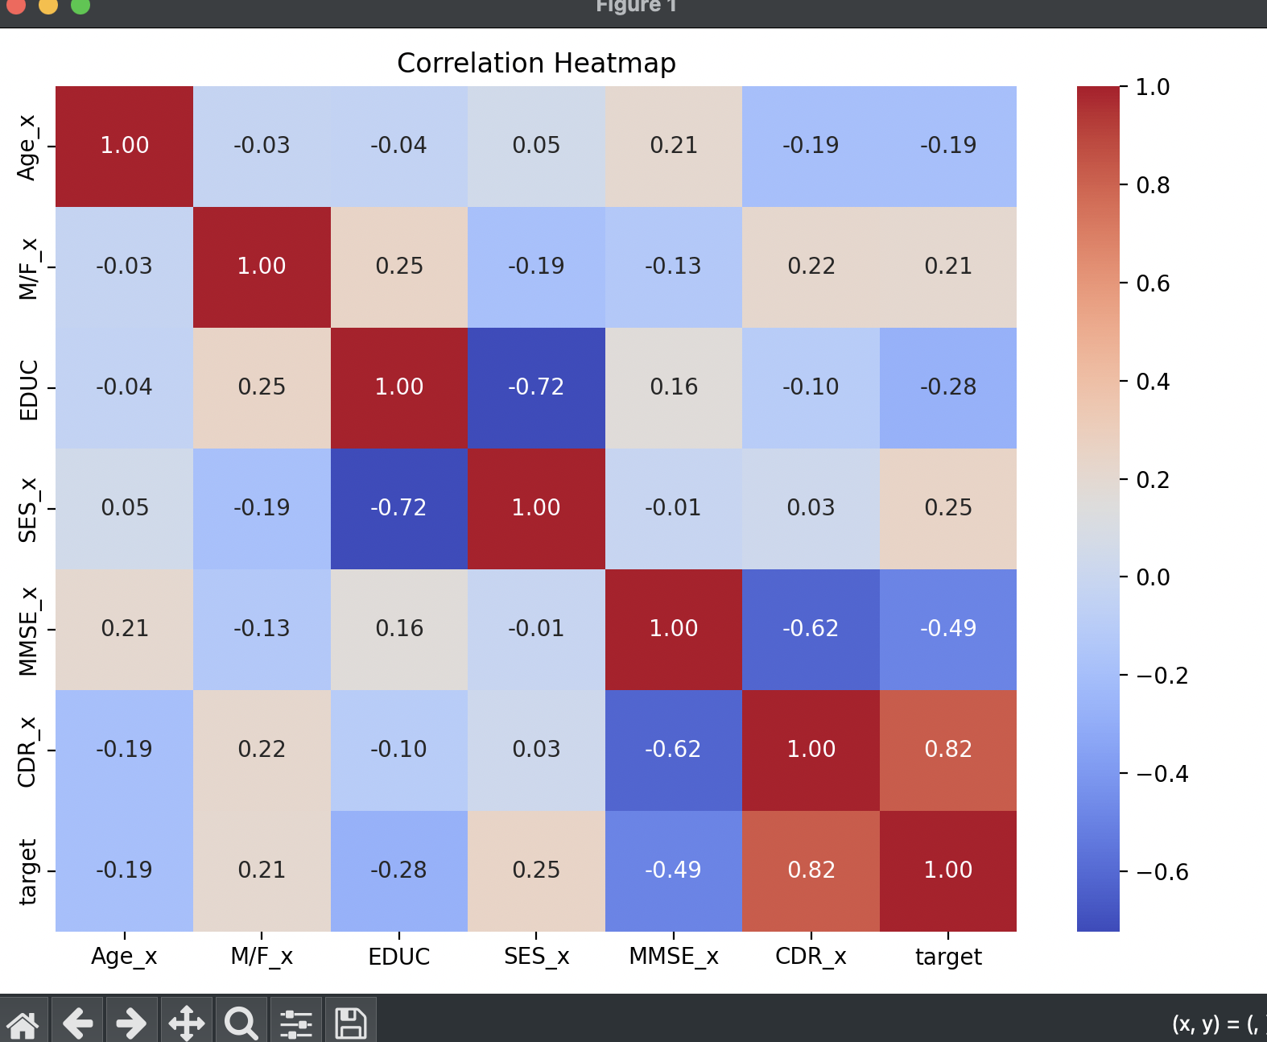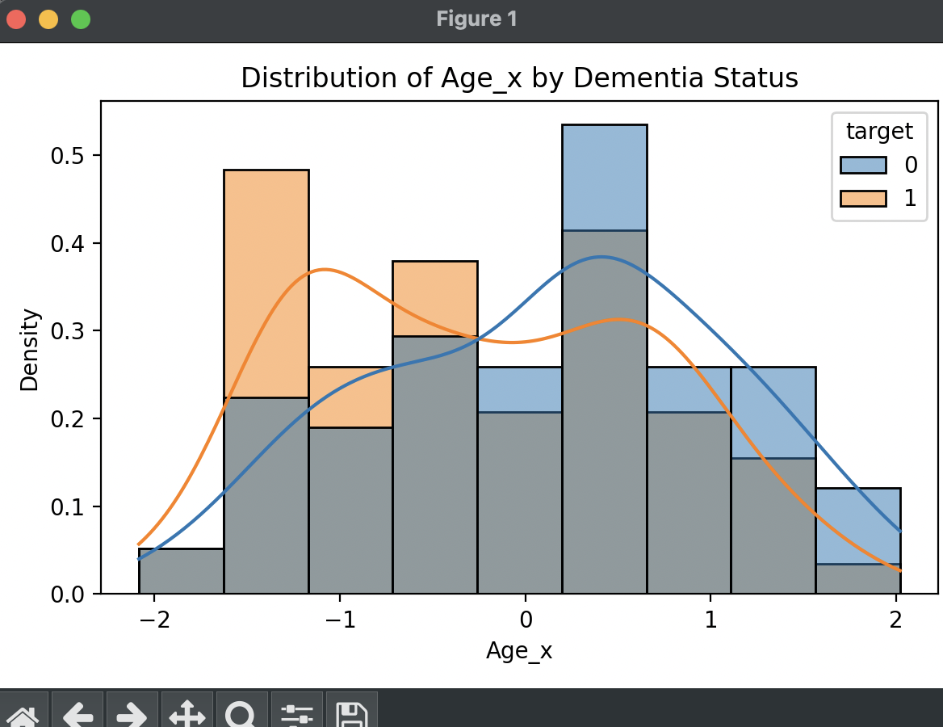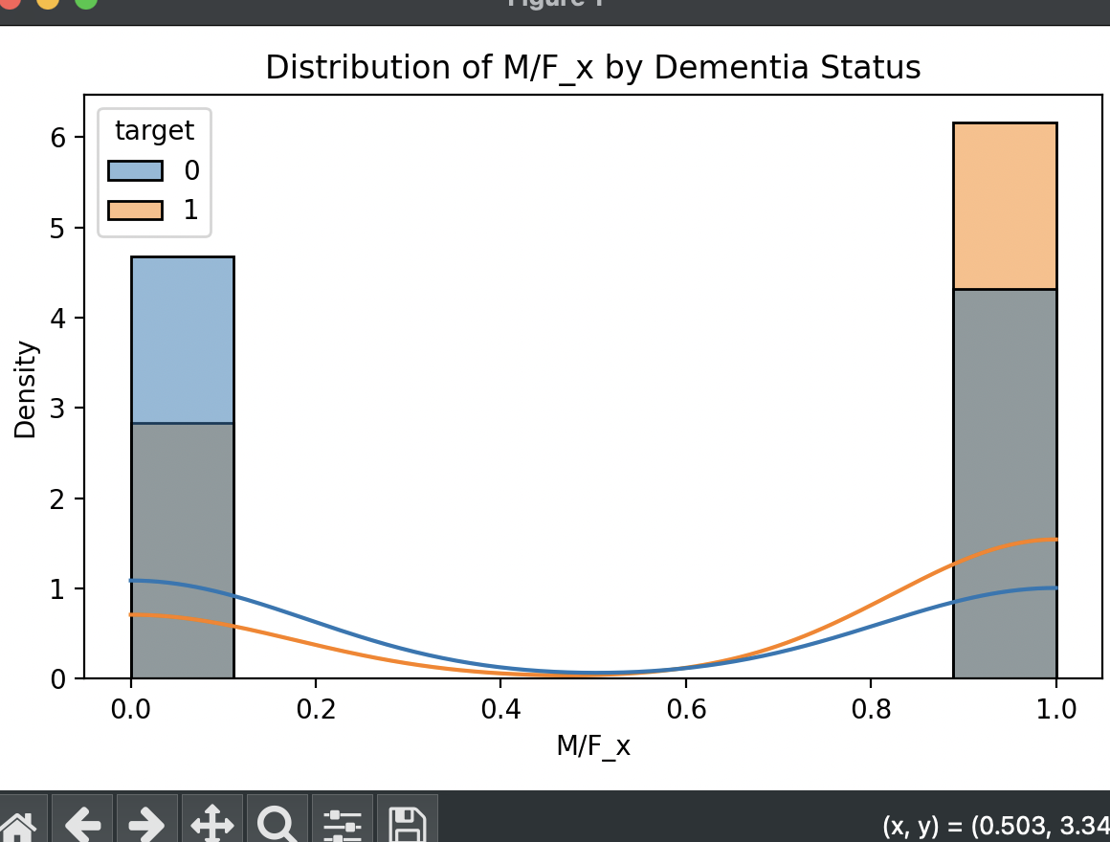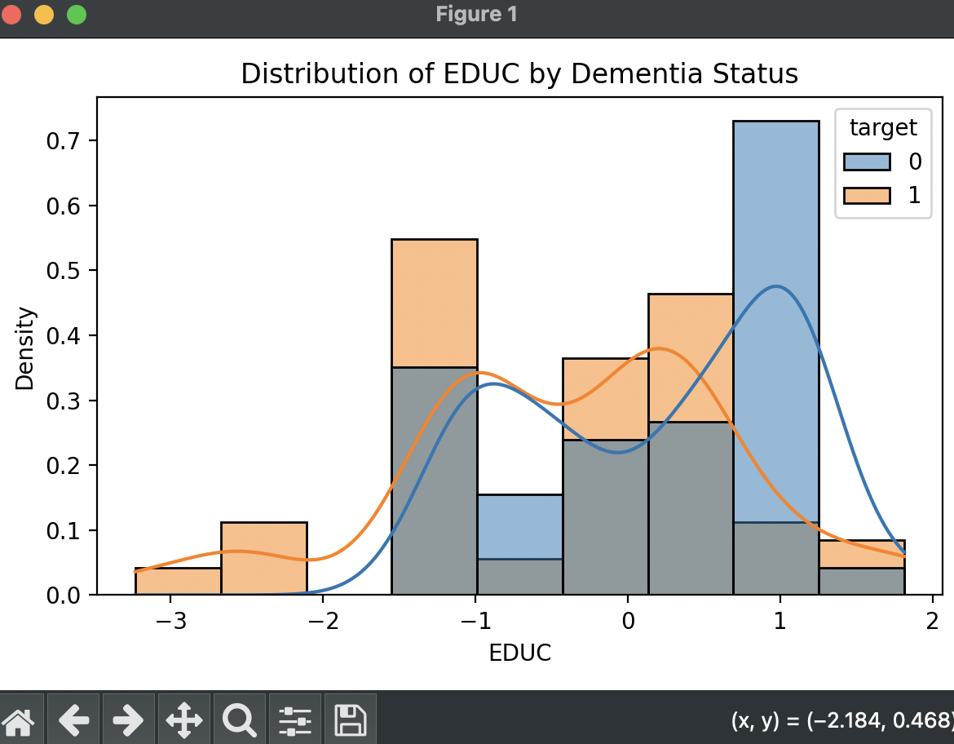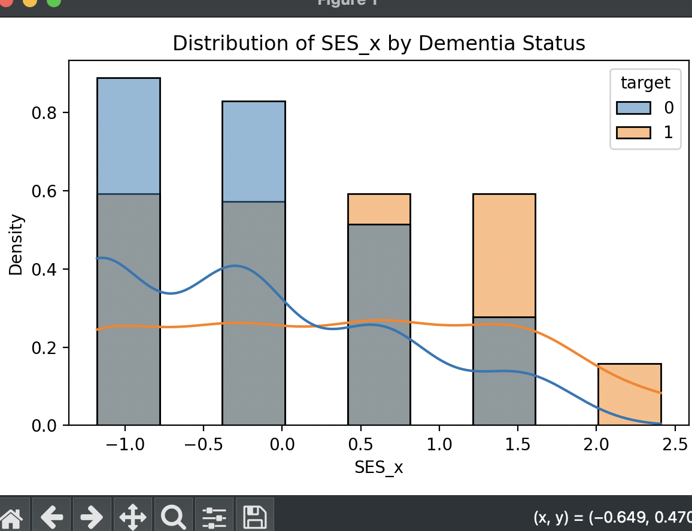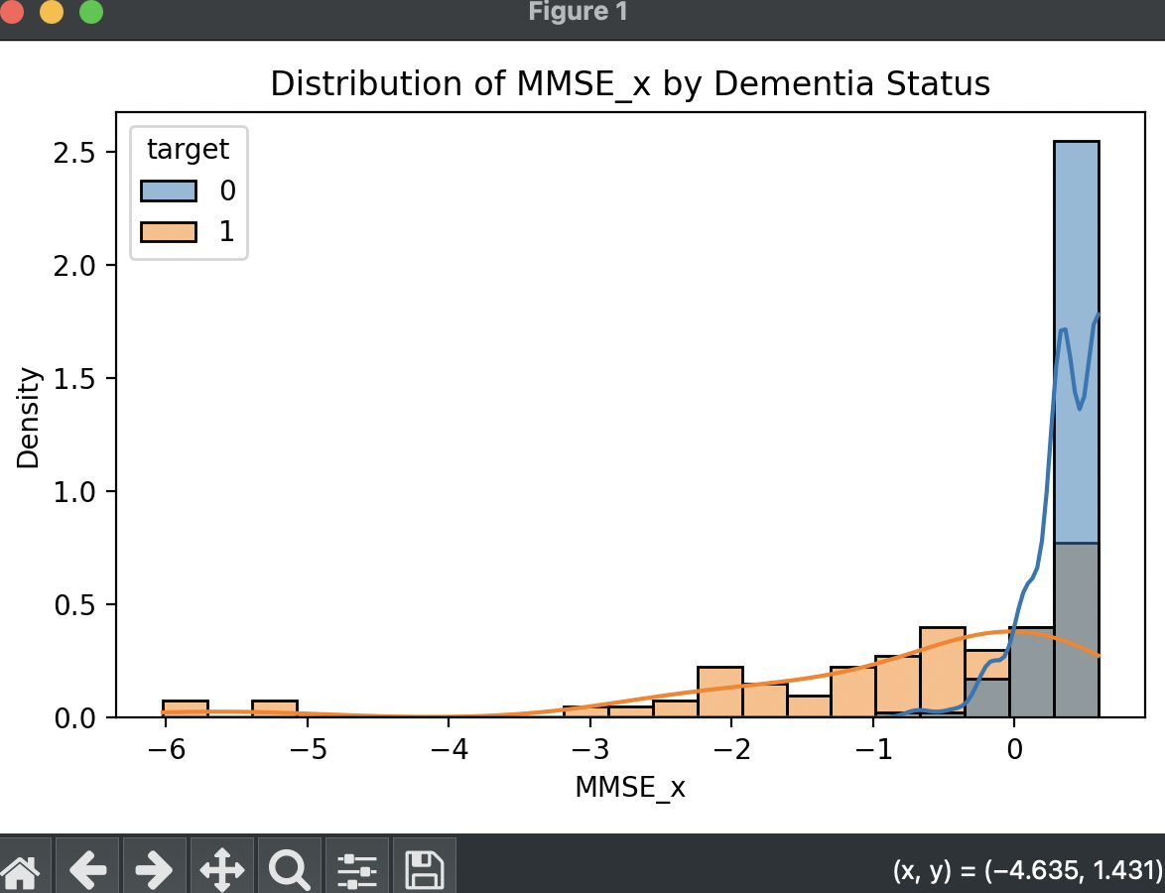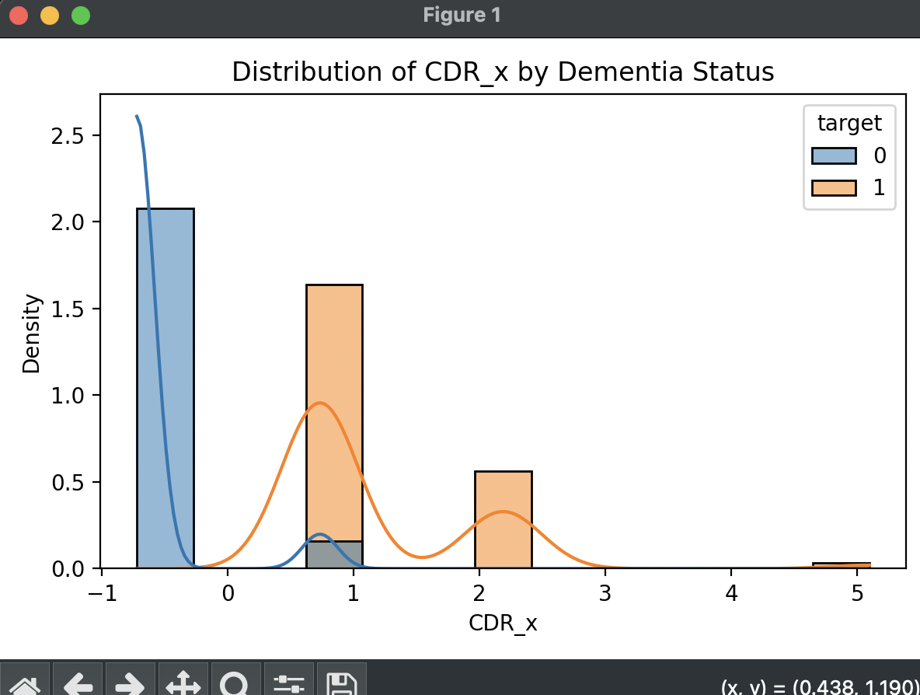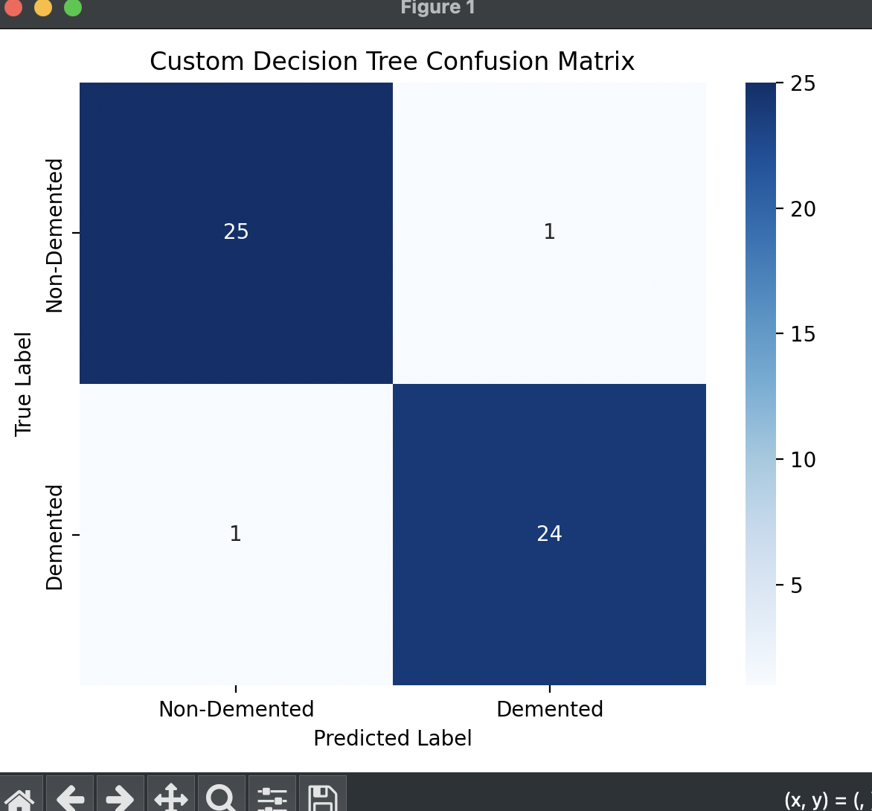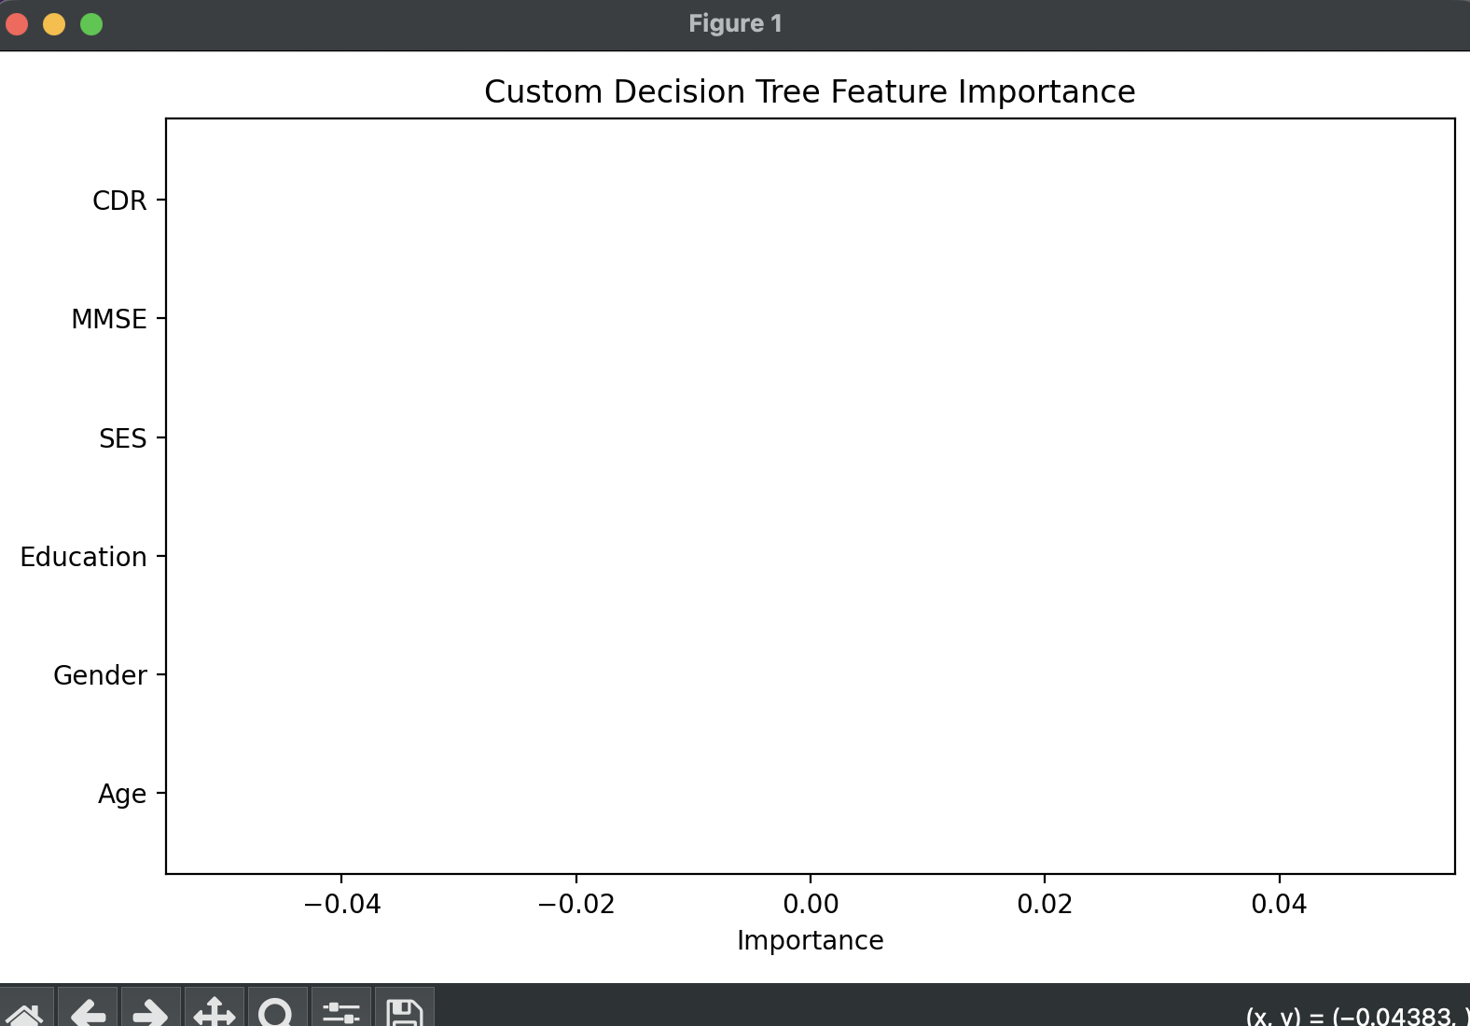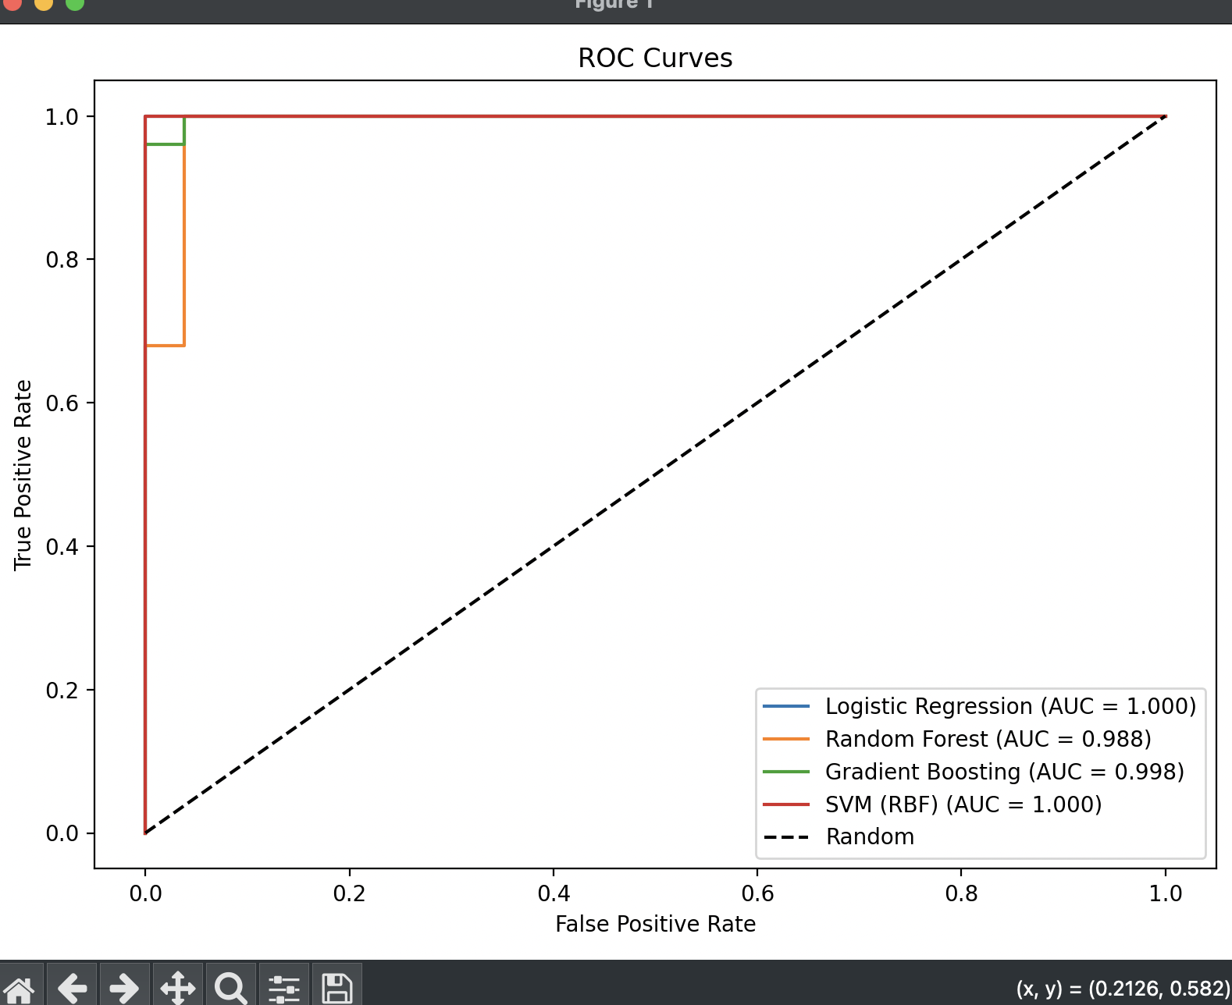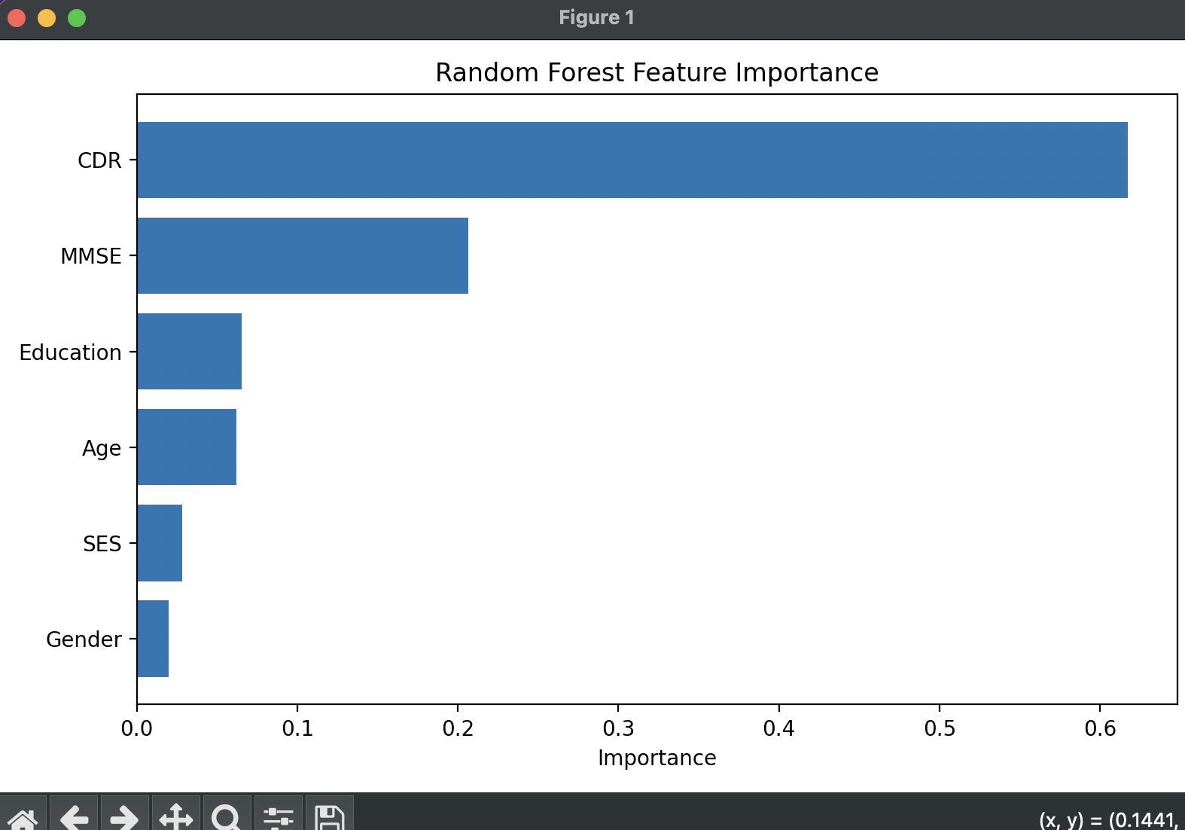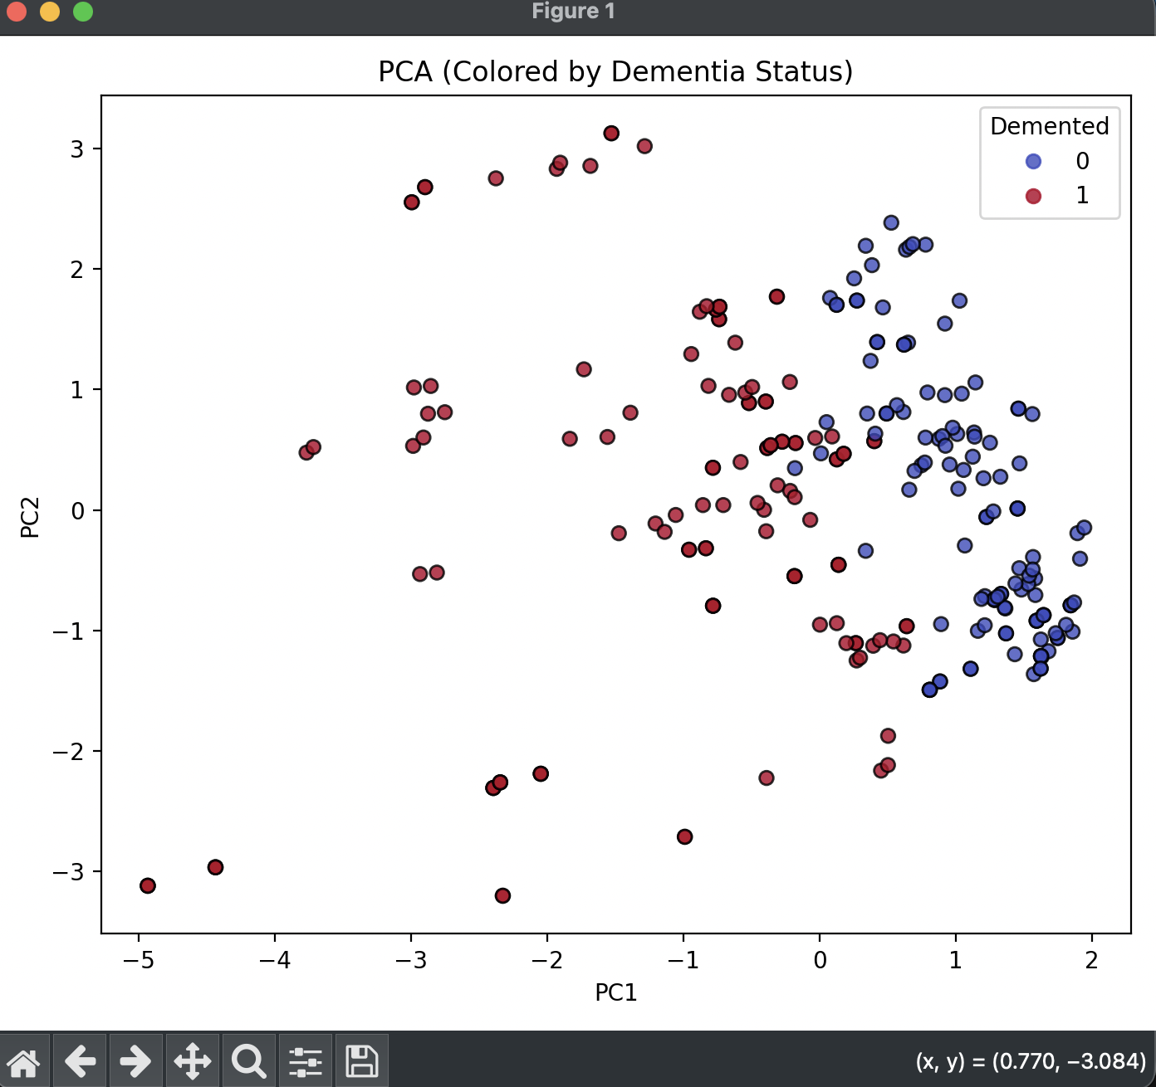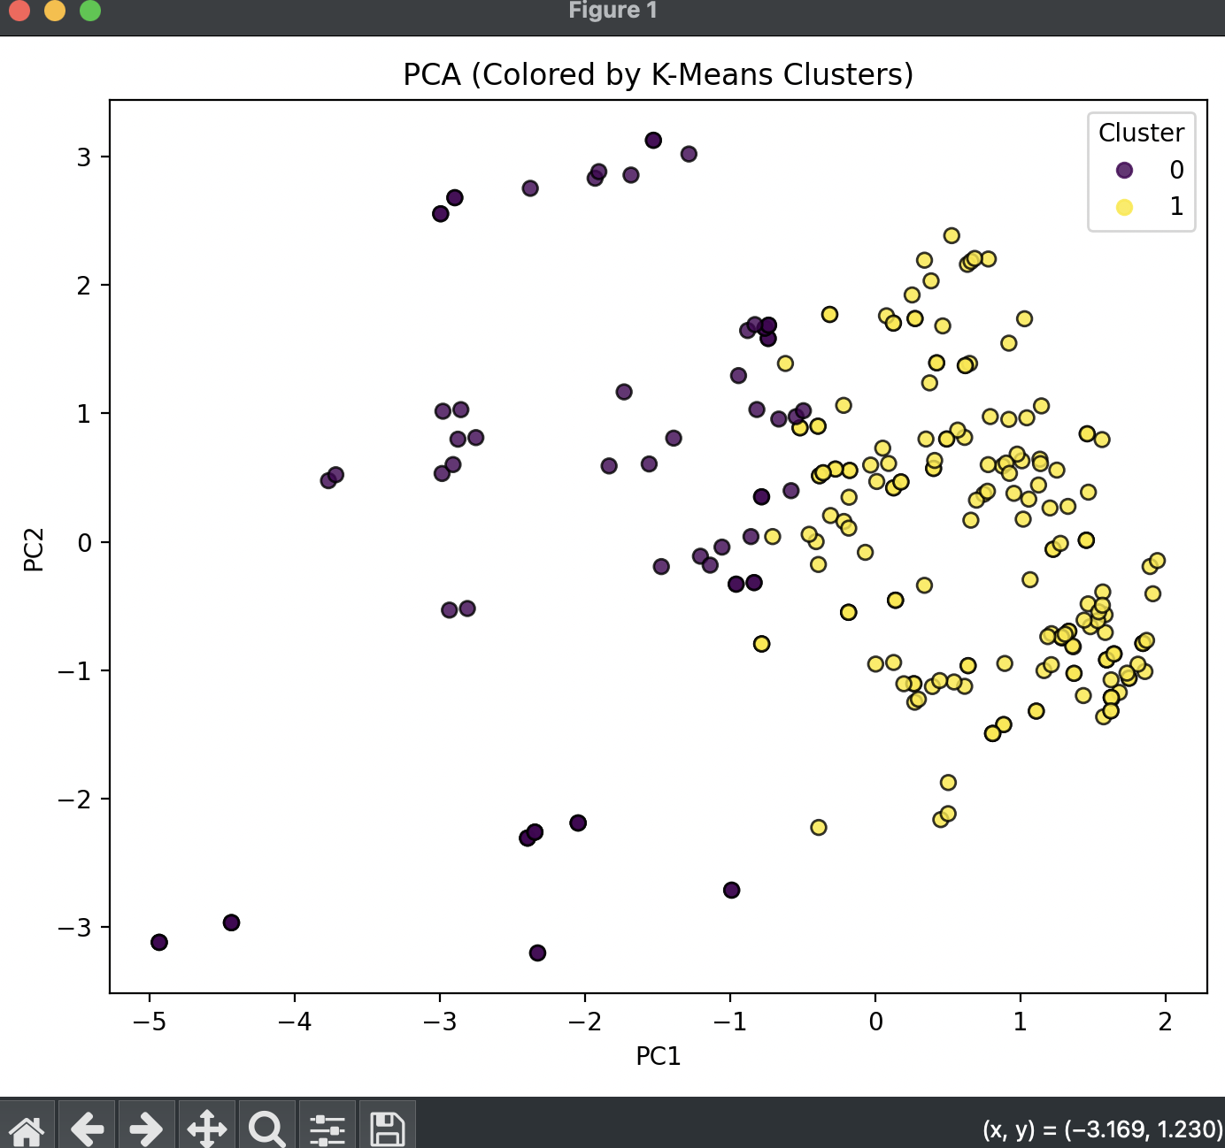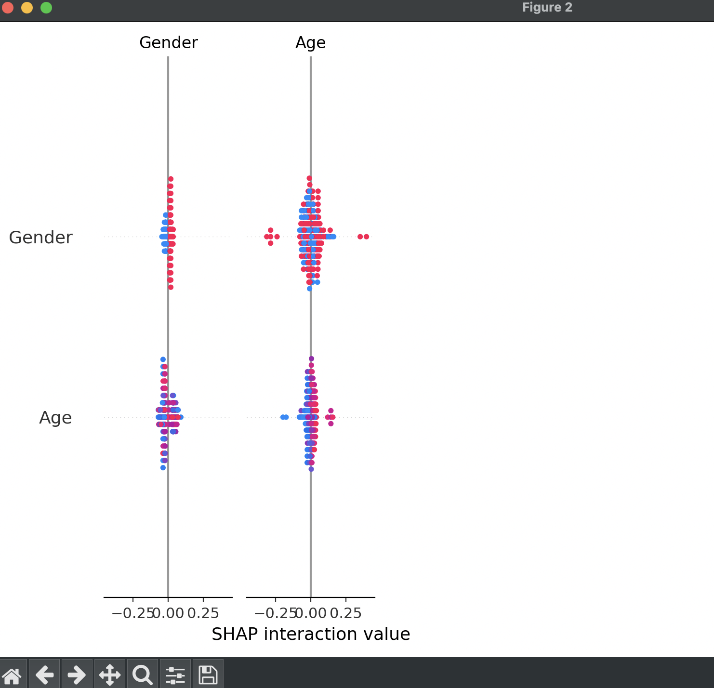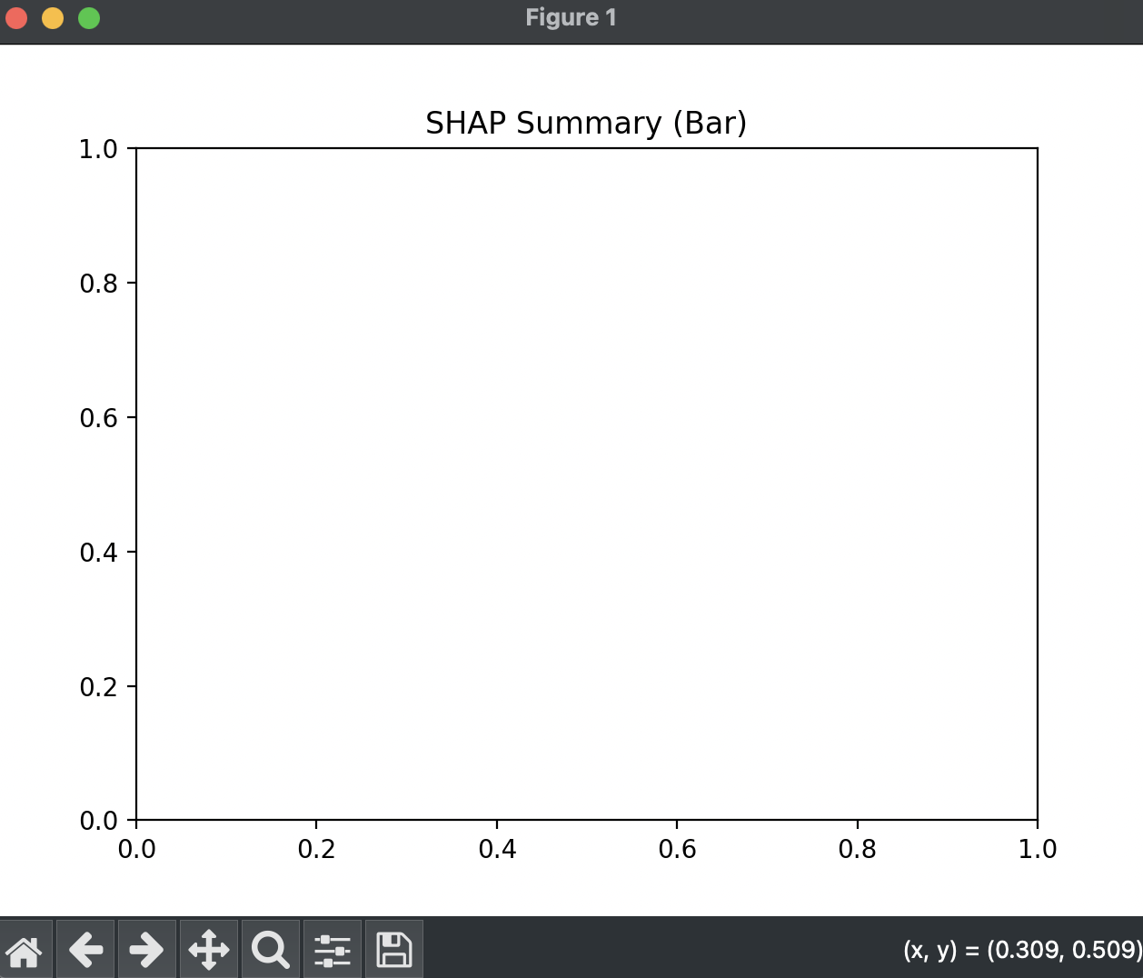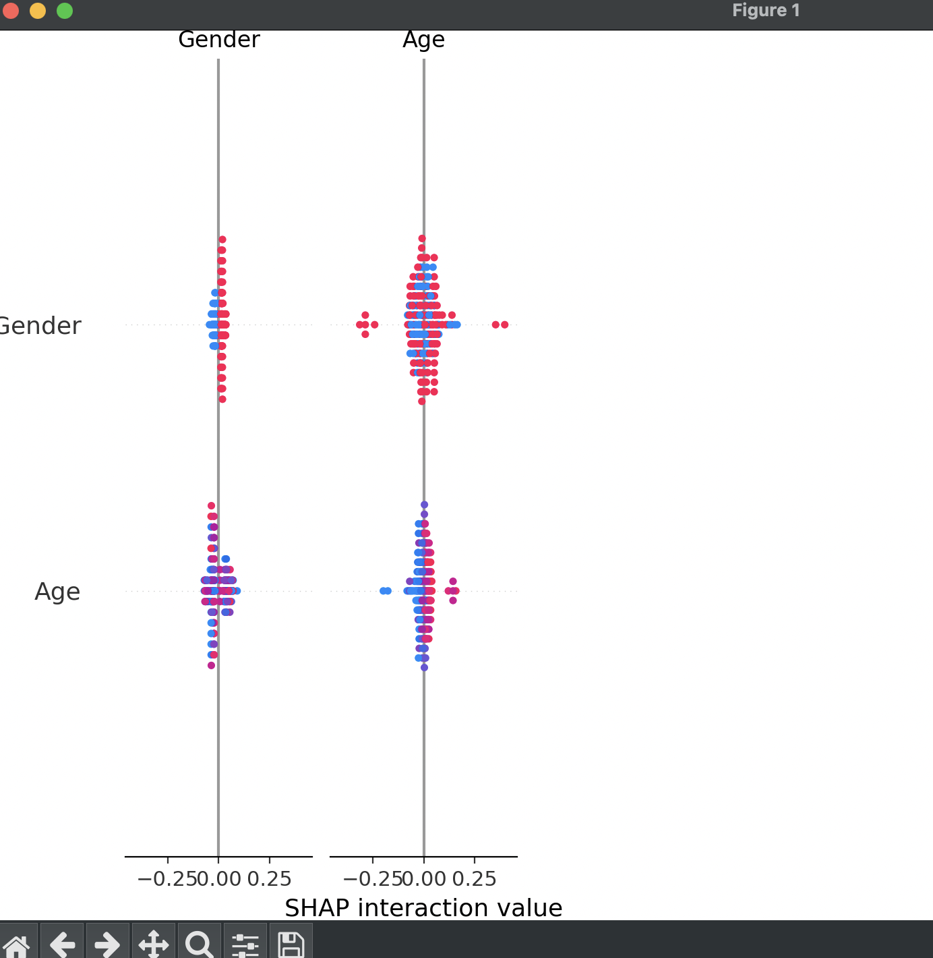

5. Discussion

The results confirm that cognitive clinical markers (MMSE and CDR) are the dominant predictors of dementia. Machine learning models demonstrated exceptional classification performance, suggesting a strong linear and nonlinear separation within the dataset. Demographic variables exhibited minimal predictive influence, corroborated by statistical test results.

6. Conclusion

This research demonstrates that machine learning offers a powerful and interpretable framework for dementia prediction. Statistical evidence and model explainability both confirm the supremacy of clinically validated cognitive assessments.

Acknowledgements
The author acknowledges the OASIS project team for dataset availability and Stockton University’s Data Mining faculty for guidance.

Appendix A: Code Repository
The full project code includes preprocessing pipelines, model training scripts, explainability modules, and visualization utilities.

